**Fall (October) 2018**

Dear GR Members:

At the end of the calendar year 2018, I will have completed a two-year term as President of Golden Racquets. They have been interesting and sometimes challenging years. As noted below, during these past two years the Four Seasons Tennis Club has closed and Golden Racquets has begun to place venues at the Arlington YMCA Tennis and Squash Center as well as expanding play at the Burke Swim and Tennis Club. Fortunately, Golden Racquets took steps to find suitable replacement courts for indoor play well in advance of Four Seasons closing.

As expected, with the reduced supply of indoor tennis courts, court fees are rising. Also, there is increased competition for courts with the existing clubs' own members. Many Golden Racquets members live on fixed incomes and may have trouble paying the higher venue costs.

The search and negotiations for replacement indoor tennis facilities stretched traditional Golden Racquets methods of contracting for courts. We faced a very different environment than I believe was encountered in the earlier years of Golden Racquets. For instance, several of the tennis clubs we approached would require Golden Racquets members who played at their facilities to also be members of the clubs themselves. That has never been the practice of Golden Racquets. The Arlington YMCA is one club that requires players on their courts to be members of the YMCA.

In the past, most indoor tennis facilities used by Golden Racquets have been under local ownership and management. It seems that many clubs have either contracted out the management of their tennis facilities or must abide by “corporate policies” which may not give a high priority to senior citizens.

My point is that the landscape of indoor tennis in the Northern Virginia area has changed. That is why we are going to spend some time at the Annual Meeting this year discussing what the future is for Golden Racquets. I hope you will join us and lend your concerns and suggestions to the discussion.

Finally, this will likely be my last all-member communication. Janice and I are in the process of moving to Aurora, Colorado, near Denver and close to our youngest daughter and her husband and our two youngest grandchildren. I was invited to join Golden Racquets some thirteen years ago and it's been a significant part of my recreational life for these past many years. I appreciate the opportunities I've had to play enjoyable, competitive mixed doubles. Even more, I have been blessed by getting to know a great number of really good people. We've not only played with and against each other, but in many cases worked side-by-side with many of you for the good of this wonderful organization! Thank you all.

Ed Grose

~~~~~~~~~~~~~~~~~~~~~~~

**GR 2018 Annual Luncheon and Meeting**

Have you sent in your reservation to attend the Golden Racquets 2018 Annual Luncheon and Meeting? It is just around the corner, so if you have not, please send in your reservation now and join other GR members. The date of the luncheon/annual meeting is Tuesday, October 16, 2018, at PJ Skidoos restaurant, located at 9908 Fairfax Blvd., Fairfax, VA 22030 (next door to Fairfax Racquet Club). This event will begin at 11:30am, with the business meeting starting at 12:30pm.

Topics of discussion and business that will be held at this year's meeting include:

* Golden Racquets Outstanding Member of the Year presentation
* Election of officers
* The future of Golden Racquets Organization
* Awarding of door prizes

You can see that this will be a fun luncheon & meeting, as well as a very important one. So sign up now -- it's not too late!

~~~~~~~~~~~~~~~~~~~~~~~

**I'm Old Enough That . . .**

**by CJ Dieteman**

"There are days that I feel particularly "Golden," the older age implied by "Golden Racquets." And then I'll have a match like one recently. On a water break, we started giving our ages. One was 78, one was 84, a third was 85, and I am only 72. For the rest of the match, I was referred to as "young man."

"Still, I *am* old enough that . . .

* I was born closer to World War I than to Desert Storm;
* I purchased my first tennis racket with S&H Green Stamps (and obviously it was a wooden racquet!);
* 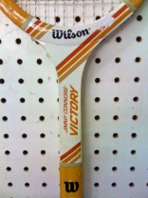We had a house with coal heat;
* We had a four digit phone number, on a party line;
* When the county worked on the road in front of our house they used round metal pots with oil burners rather than battery operated warning flashers;
* My first elementary school danced a "May Pole";
* We listened to *Jack Benny* and *Gunsmoke* on the radio;
* I had the original Salk polio shots;
* I used phone booths that charged 5 cents;
* My family had a friend who had a tattoo indicating he was a concentration camp survivor;
* I played softball with a veteran of the Battle of the Bulge;
* and I worked with a man who was at Pearl Harbor on December 7, 1941.

"I can only imagine the sorts of things that the other guys in that match could come up with. I can also imagine that there are lots of GR members older than I who could also come up with an interesting list.

"I hope some will."

~~~~~~~~~~~~~~~~~~~~~~~

**The Lost Civil War Diary of John Rigdon King**

**by Don Jenkins**

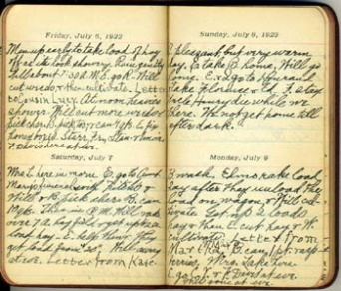"On a crisp fall day in October of 1861, a precocious, seventeen year-old boy went into a store in his hometown of Hagerstown, Maryland, and purchased a composition book for use as a diary. Over the ensuing months, John R. King steadfastly recorded what he did, saw, and heard daily, as the Civil War raged around him. In March of 1862, when he traveled to the Shenandoah Valley, John started selling goods to Union troops in their camps while also taking portrait photographs. Then, on May 23, 1862, when he heard the sounds of battle nearby, he attempted to flee with his wagon. Instead, he was captured by Stonewall Jackson’s troops. His treasured diary was seized. As he was marched to a Confederate prison, John vowed revenge. Two weeks after escaping from captivity in August, John joined the Union Army. He fought with fury, courage, and valor. He was wounded three times and became a war hero. Later, John was not only appointed by two Presidents to prestigious positions in the Pension Bureau, but he also was made Commander-in-Chief of the largest Union veteran’s organization, the Grand Army of the Republic."

After being lost for 142 years, John R. King’s diary was found by Don Jenkins, a Golden Racquets member. It is probably the only known Civil War diary written by a teenager who was also a photographer. After transcribing the diary, Don began writing a book based on John’s diary and on King’s fascinating post-war life. Don’s non-fiction narrative, *The Lost Civil War Diary of John Rigdon King*, is being released October 29, 2018, by Arcadia Publications, well-known for their America Through Time series

~~~~~~~~~~~~~~~~~~~~~~~

**Pet Peeves from GR Members**

The following "pet peeves" were submitted by GR members:

* Return of Service that is Obviously Out: "I have found some players return serves that are clearly faults. When a player returns a serve that is clearly out, it is disruptive to the server and very often takes time from the play. If the returned out-serve hits the net without going over the net, the receiver's of the serve must stop play to pick up the ball and get it out of the way for the safety of the players. If the returned out-serve goes over the net, the server's of the serve must stop play to pick up the ball get it out of the way for the safety of the players. In either event, play must be stopped to retrieve a serve that was no good in the first place. If the serve is long or no good, the receiver should either let it roll to the back of the court, or if possible, catch it and put it in their pocket."
* Practice of Serve: "My pet peeve has to do with players practicing serves after the ground stroke practice is done and before play starts. I have observed that this takes too long and too often players hit more than one round to the same court. This squeezes the time for play considerably. To combat this I would like GR to send out a directive that bans, or at least discourages, practicing serves during warm-ups. Instead, players should be given the option of either playing first-in or to hit no more than three practice serves to the deuce court when it is their time to serve. This would lead to a more efficient use of court time and increase playing time."

|  |
| --- |
| Do you have a tennis pet peeve that you would like to see addressed for the benefit of all? Please share it with us and we will get some helpful suggestions to you in the next newsletter. |

~~~~~~~~~~~~~~~~~~~~~~~

**And Now, the End of an Era . . .**

**by Connie Dineen**

The long-rumored closing of the Four Seasons Tennis Club became a rumor no longer in the summer of 2018. We have heard this rumor for years -- and hoped it was not true for even longer -- but it did come to pass with great sadness for many, many tennis players in the DC/NOVA region this past summer. As members of the Four Seasons Tennis Club since the 1970's, it seemed like our "tennis home" to my husband and I, and we played many, many matches there. Starting with our Friday night and Saturday afternoon season times, we played there with other couples, some of whom we met on the next court and with whom we became life-long friends. We took lessons and clinics from the pros there, began playing many of our USTA League matches there, and in the most recent years, played in the GR venues that were held there. All were great fun and provided us with lasting and wonderful memories. I am sure you have wonderful memories as well. So keep those memories and add to them by continuing to play tennis -- it will just have to be somewhere other than the Four Seasons Tennis Club.

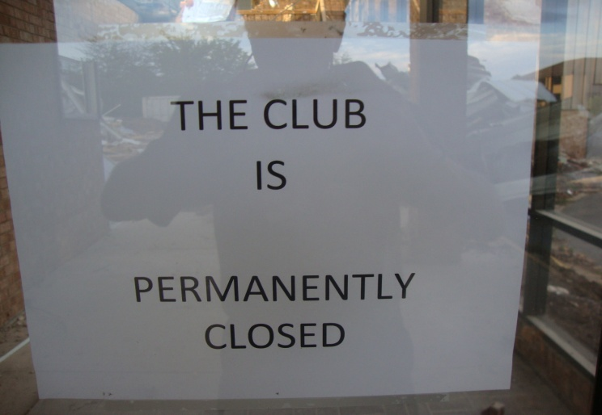





~~~~~~~~~~~~~~~~~~~~~~~

**A Few Fun Facts**

* There are 293 ways to make change for a dollar.
* A cat has 32 muscles in each ear.
* Al Capone's business car said he was a used furniture dealer.
* There are 336 dimples on a regulation golf ball.
* An ant can lift 50 times its own weight and pull 30 times its own weight.
* 'Stewardesses' is the longest word that is typed with only the left hand.
* Alaska is the state with the highest percentage of people who walk to work -- brrrr!

**To have an article or picture of interest considered for inclusion in the Golden Racquets Newsletter, please send them to Connie Dineen at:**

[csdineen51@gmail.com](mailto:csDineen51@gmail.com)

NOTE: Articles may be of general interest and do not necessarily need to be about tennis.



**This Golden Racquets Newsletter is published by the Fairfax County Golden Racquets, a non-profit volunteer organization dedicated to senior tennis. You are encouraged to visit the Golden Racquets website at http://www.Golden Racquest.org. Officers and committee chairs are as follows:**

President: Ed Grose

Immediate Past President: CJ Dieteman

Vice President: Laura Riesenberg

Secretary: Claudia Steichen

Treasurer: Al McFarland

Membership Chair: Adele Neuberg

Rating Committee Chair: Tom Burroughs

Social Committee Chair: Howard Ho

Caring Committee Chair: Bala Balakrishnan

Chief Information Officer: Bob Dineen

Operations & Planning Chair: Fred Hart

Web Site Manager: Lindsay Wozniak

Newsletter Editor: Connie Dineen